## MUTEC Signs Tom Porcell to Boost Sales Team

*February 2018, Berlin*. MUTEC GmbH, manufacturer of professional and audiophile consumer audio equipment, has signed Tom Porcell to boost its sales team. Since the beginning of the year Tom Porcell is now supporting the sales and support departments in German-speaking territories.

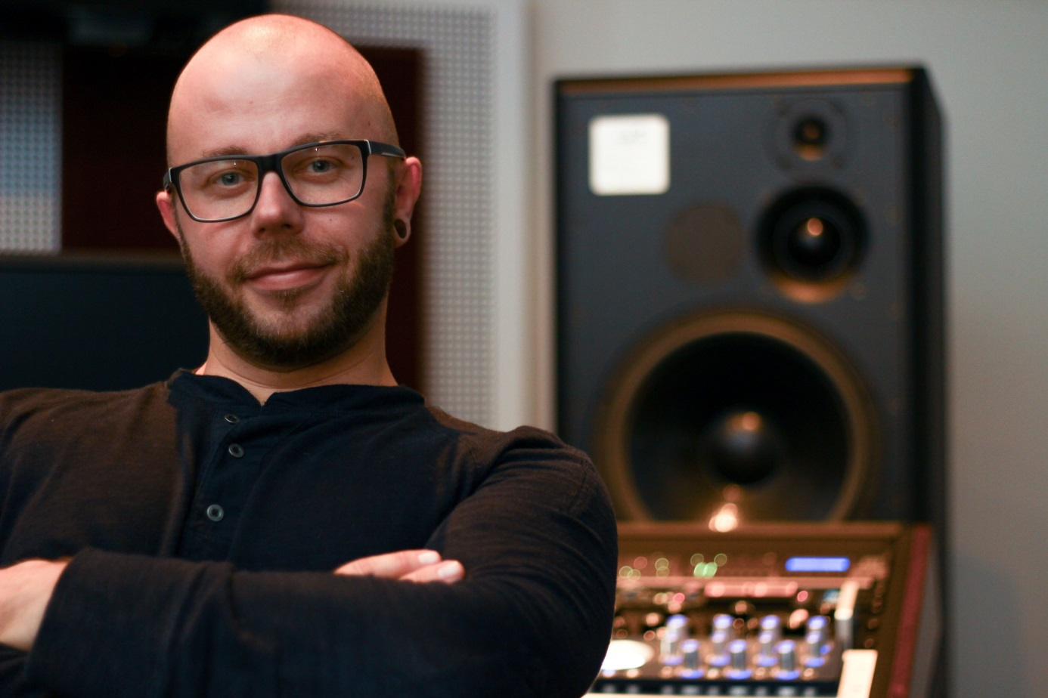

Tom Porcell, the new sales and support specialist, in his mastering suite.

Having his feet both in the mastering world and in pro audio and hifi sales for several brands Tom Porcell has racked up more than 20 years of experience in the music business. He currently freelances for HP Mastering in Germany and has just received a Gold record for his mastering work on the track “Burden Down” by electronic/dance artist Micar. On the pro audio side of the business his track record includes sales, artist relations, and product specialist work for Antelope Audio and Amphion loudspeakers. With his expertise as a mastering engineer he is intimately familiar with the application of high-end audio gear and a promising addition to the MUTEC team.

“*I’m very much looking forward to this new opportunity at MUTEC. As soon as I heard these products in my mastering suite I was instantly impressed. I’m thrilled to get to know MUTEC’s customers who share the same passion for perfection as I do.”, explains Tom Porcell.*

It’s this passion for perfection combined with his musical ear and attention for detail in mastering that are an ideal match for MUTEC’s aspirations and brand philosophy of merging music and technology. Hence, MUTEC’s CEO Christian Peters sums up his expectations for the future as follows:

*“I’m very excited about the addition of Tom Porcell to coordinate our German dealer network. Tom has extensive experience in the German pro audio and high-end consumer audio markets. As such he has successfully introduced other brands to these markets. I’m confident that his expertise and contacts will help us reach a wider range of dealers to continue establishing the MUTEC brand. Tom Porcell will also be in charge of some internal tasks such as online customer support. This further means that he will be the point person for technical support questions from our dealers. I’m very optimistic about our liaison and look forward to working with Tom.”*

**About MUTEC**

MUTEC is a leading manufacturer of high-quality A/V master clocks, audio re-clockers, interfaces, format converters, and signal distributors for professional and audiophile consumer audio applications. Focusing on improving digital audio reproduction and transmission processes, MUTEC’s 1G-Clock Technology raises the bar for ultra-low jitter clock generation industry-wide to an unparalleled level of performance. Based in Berlin, Germany, MUTEC is dedicated to setting new standards in sound quality, clock generation and digital audio signal processing, enabling customers to realize their visions of the perfect sound in their environments.

MUTEC products are installed in leading-edge broadcast and television stations, well-respected recording and mastering studios as well as renowned musical theatres, opera houses and universities all over the world. The new line of audiophile consumer products takes our experience from the broadcast and pro audio world into the listening room at home to provide an unprecedented music experience.

For further information please contact us directly.

MUTEC GmbH

Presse-Abtl.

Email [press@mutec-net.com](mailto:press@mutec-net.com)

Web [www.mutec-net.com](http://www.mutec-net.com)

Fon 0049-30-746880-0