Audiofast to distribute MUTEC’s HiFi products in Poland

July 2018, Berlin. Audiofast, Poland’s leading high-end audio distributor is now the official distribution partner for MUTEC’s HiFi products like the MC-3+ Smart Clock USB and the REF 10 Reference Master Clock. The deal was closed at the recent High End show in Munich, where MUTEC exhibited for the third time.

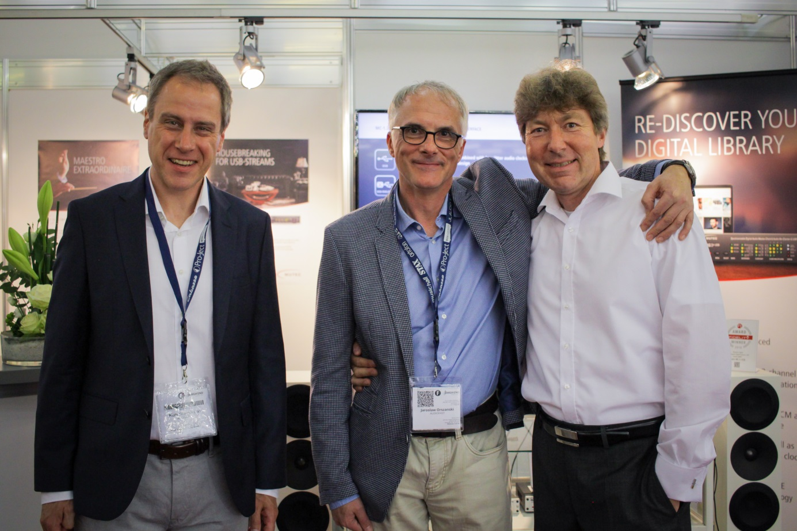
Audiofast’s Sales Manager Piotr Stachowski and CEO Jaroslaw Orszanski with MUTEC’s CEO Christian Peters at High End 2018 (pictured left to right).

Key take-aways of this press release:
- Audiofast is MUTEC’s new distributor for HiFi products in Poland
- MUTEC joins a portfolio of premium brands like dCs, MSB Technology, and Aurender
- The signing reinforces MUTEC’s position as a manufacturer of high-end consumer audio
- The partnership brings MUTEC products to a new market in Eastern Europe
With a wide-ranging portfolio of top-shelf HiFi brands and several dealers across Poland, Audiofast is the ideal partner for expanding MUTEC’s reach in the buzzing Eastern European high-end market. As the exclusive Polish distributor for premium brands such as dCs, MBS Technology and Aurender, Audiofast is clearly dedicated to high-end consumer audio and has the experience to tell the MUTEC story to Polish customers.

Effective immediately Audiofast will be distributing all of MUTEC’s high-end consumer audio products such as the flagship REF 10 Reference Master Clock, the MC-1.2 USB audio interface, and the MC-3+ Smart Clock USB. The latter uniquely combines MUTEC’s proprietary REVIVE Re-Clocking process with a sophisticated USB isolator interface and the 1G-Clock technology proven by many years in the trenches with pro audio mastering engineers such as Maor Appelbaum and Dave Kutch (The Mastering Palace NYC). The REF 10 on the other hand has quickly established itself as the industry-leading 10 MHz reference master clock thanks to its unmatched phase noise performance, integration compatibility, and empyreal sound quality.

“We couldn’t think of a better distribution partner for Poland than Audiofast”, comments Christian Peters, chief executive officer at MUTEC GmbH. He adds: “when meeting Jaroslaw Orszanski and Piotr Stachowski personally at the recent High End show in Munich it quickly became clear that they share the same passion and expertise for high-end audio as we do at MUTEC. Our REF 10 Reference Master Clock is a wonderful addition to dCs products like the Vivaldi and Rossini Master Clocks that I’m convinced a lot of customers will appreciate.”

Audiofast’s CEO Jaroslaw Orszanski sums up his expectations for the distribution partnership as follows: “I am very excited to establish the cooperation with such a high-technology firm as MUTEC. From the first conversation with Christian Peters, I knew that we think in the same way about high-end. I’m sure that our partnership will result in a long-term and fruitful friendship, which will be very beneficial for both companies. We will do our best to make it happen.”

Picture assets:
https://www.dropbox.com/s/k6jahlxxjlw119m/MUTEC_Audiofast_HighEnd.jpg?dl=0

About MUTEC
MUTEC is a leading manufacturer of high-quality A/V master clocks, audio re-clockers, interfaces, format converters, and signal distributors for professional and audiophile consumer audio applications. Focusing on improving digital audio reproduction and transmission processes, MUTEC’s 1G-Clock Technology raises the bar for ultra-low jitter clock generation industry-wide to an unparalleled level of performance. Based in Berlin, Germany, MUTEC is dedicated to setting new standards in sound quality, clock generation and digital audio signal processing, enabling customers to realize their visions of the perfect sound in their environments.

MUTEC products are installed in leading-edge broadcast and television stations, well-respected recording and mastering studios as well as renowned musical theatres, opera houses and universities all over the world. The new line of audiophile consumer products takes our experience from the broadcast and pro audio world into the listening room at home to provide an unprecedented music experience.
For further information please contact us directly.
MUTEC GmbH
Presse Department

Email press@mutec-net.com
Web www.mutec-net.com
Fon 0049-30-746880-0

