## Luen Hing Electrical to Expand Reach of MUTEC’s HiFi Products to Mainland China, Taiwan, and Macau

*August 2018, Berlin and Hong Kong*. Luen Hing Electrical (H.K.) Ltd., MUTEC’s existing HiFi distribution partner for Hong Kong, has just been enlisted with also distributing MUTEC products in Mainland China, Taiwan, and Macau. With the annual Hong Kong High End Audio Visual show just around the corner, the deal comes at a perfect time to showcase MUTEC’s products to a broad Asian audience.

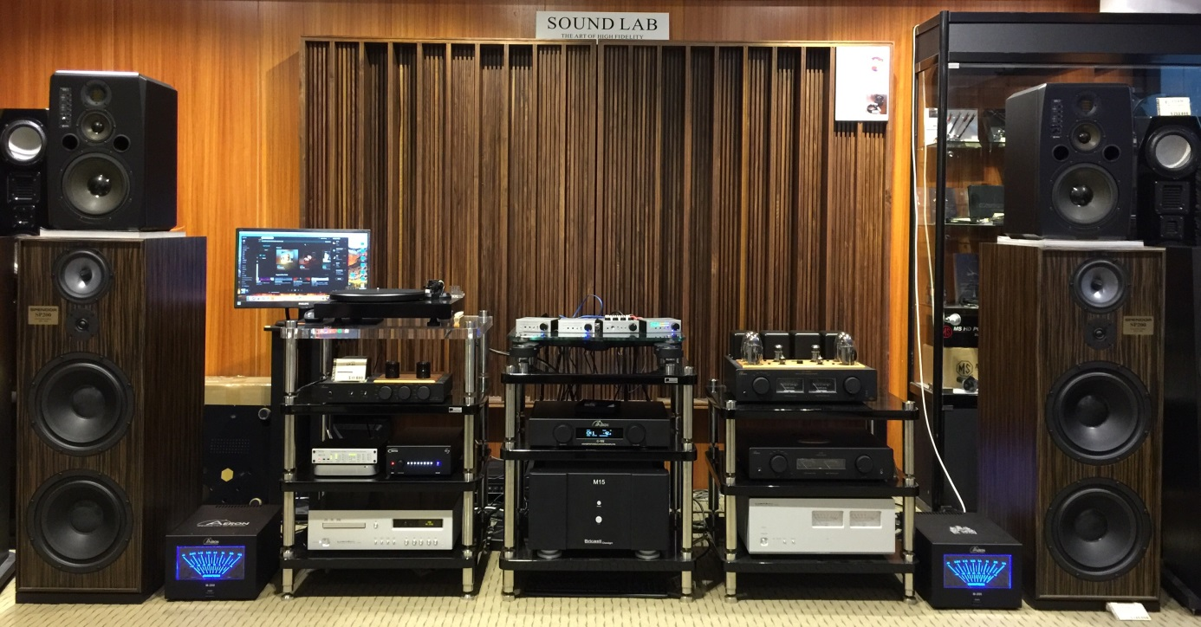

The "Sound Lab", one of Luen Hing Electrical’s show rooms.

Key take-aways of this press release:

* Luen Hing Electrical (H.K.) Ltd. is MUTEC’s new distributor for HiFi products in Mainland China, Taiwan, & Macau
* MUTEC joins a portfolio of premium brands such as Burmester, Linn, and Cambridge Audio
* The partnership drastically expands MUTEC’s reach in Asia
* The signing reinforces MUTEC’s position as a manufacturer of high-end consumer audio

Luen Hing Electrical (H.K.) Ltd. joins a growing number of MUTEC distributors specialized in distributing high-end consumer audio products, such as the recently signed Audiofast in Poland. As MUTEC’s existing distributor for HiFi products in Hong Kong, Luen Hing Electrical (H.K.) Ltd. is already intimately familiar with the benefits and features of core MUTEC developments such as the REVIVE Re-Clocking and 1G-Clock technologies. With a growing roster of exclusive top-shelf audiophile brands such as Burmester, Linn, Cambridge Audio, and Aeron, the distributor is an ideal partner with full dedication to high-end audio to reach even more music lovers in Asia.

Effective immediately Luen Hing Electrical (H.K.) Ltd. will be distributing all of MUTEC’s high-end consumer audio products such as the flagship REF 10 Reference Master Clock, the MC-1.2 USB audio interface, and the MC-3+ Smart Clock USB. The latter uniquely combines MUTEC’s proprietary REVIVE Re-Clocking process with a sophisticated USB isolator interface and the 1G-Clock technology proven by many years in the trenches with pro audio mastering engineers such as Maor Appelbaum and Dave Kutch (The Mastering Palace NYC). The REF 10 on the other hand has quickly established itself as the industry-leading 10 MHz reference master clock thanks to its unmatched phase noise performance, integration compatibility, and empyreal sound quality.

Lawrence Lau, Sales and Marketing Director at Luen Hing Electrical (H.K.) Ltd., comments on the deal: *“I am very proud to be a member of the MUTEC family! First of all, thanks to MUTEC for bringing us an extraordinary product: the MC-3+ Smart Clock USB - the saviour of digital audio systems for audiophiles. For whatever digital products you use, from old school CD transports to advanced digital streaming devices, the MC-3+USB not only produces accurate musical notes but brings the music alive! I am delighted to be the distributor of MUTEC audiophile products in the Greater China region and hope to convey true music to the Chinese community.”*

*“The distribution partnership with Lawrence and his team in Hong Kong has been very successful and exciting so far, and we are very optimistic about expanding this partnership to an even bigger market*”, adds Christian Peters, MUTEC’s CEO. “*The timing couldn’t be better and we look forward to the results of the upcoming AV show in Hong Kong.”*

Luen Hing Electrical (H.K.) Ltd. will be exhibiting at booth J12 at the High End Audio Visual Show in Hong Kong, August 10-12, 2018.

**Picture assets:**

<https://www.dropbox.com/s/t4t7c0bgg9jvl4z/MUTEC_LuenHing_China_Showroom.zip?dl=1>

**Luen Hing Electrical contact:**

Luen Hing Electrical (H.K.) Ltd.

Phone: 00852-2728-8745

Email: lawrence@lhe.com.hk

Web: www.lhe.com.hk

Contact: Mr. Lawrence Lau

**About MUTEC**

MUTEC is a leading manufacturer of high-quality A/V master clocks, audio re-clockers, interfaces, format converters, and signal distributors for professional and audiophile consumer audio applications. Focusing on improving digital audio reproduction and transmission processes, MUTEC’s 1G-Clock Technology raises the bar for ultra-low jitter clock generation industry-wide to an unparalleled level of performance. Based in Berlin, Germany, MUTEC is dedicated to setting new standards in sound quality, clock generation and digital audio signal processing, enabling customers to realize their visions of the perfect sound in their environments.

MUTEC products are installed in leading-edge broadcast and television stations, well-respected recording and mastering studios as well as renowned musical theatres, opera houses and universities all over the world. The new line of audiophile consumer products takes our experience from the broadcast and pro audio world into the listening room at home to provide an unprecedented music experience.

For further information please contact us directly.

MUTEC GmbH, Press Department

Email [press@mutec-net.com](mailto:press@mutec-net.com)

Web [www.mutec-net.com](http://www.mutec-net.com)

Fon 0049-30-746880-0